**VEHICLE MANAGEMENT SYSTEM USING SALSEFORCE**

**Creating a vehicle management system using Salesforce is a great way to efficiently manage vehicles, their details, and related processes within an organization. Salesforce provides a robust platform for building such systems. Here are the general steps to create a basic vehicle management system using Salesforce:**

**1.Data Model Design:**

Create custom objects for Vehicle, Maintenance Record, Driver, etc., to store relevant information.

Define relationships between objects (e.g., each Maintenance Record is related to a specific Vehicle).

**2.User Interface:**

Design custom Salesforce Lightning components and pages to input and display vehicle information.

Implement intuitive user interfaces for adding/editing vehicles, maintenance records, and driver details.

**3.Automation and Workflow:**

Set up automation rules, such as workflows and process builder flows, to automate tasks like assigning vehicles to drivers, scheduling maintenance, and sending notifications.

Use validation rules to ensure data integrity.

**4.Integration:**

systems for real-time Integrate with external systems if necessary, for example, integrating with GPS vehicle tracking.

**5.Reporting and Dashboards:**

Create custom reports and dashboards to visualize vehicle usage, maintenance schedules, and driver performance**.**

**6.Mobile Access:**

Build a mobile-friendly interface using Salesforce Mobile App, allowing users to access the system on the go.

**7.Security and Access Control:**

Implement Salesforce profiles and permission sets to control user access to different parts of the application.

Use field-level security to restrict access to sensitive information.

**8.Testing and Deployment:**

Thoroughly test the system to ensure all functionalities work as expected.

Plan a deployment strategy and use Salesforce's deployment tools to move the solution from sandbox to production.

**9.Training and Support:**

Provide training to users on how to use the system effectively.

Set up a support mechanism for users to report issues and seek assistance.

Remember, the specifics of your vehicle management system might vary based on your organization's requirements, so it's important to tailor the above steps accordingly. Salesforce's extensive documentation and community resources can be valuable references during the development process

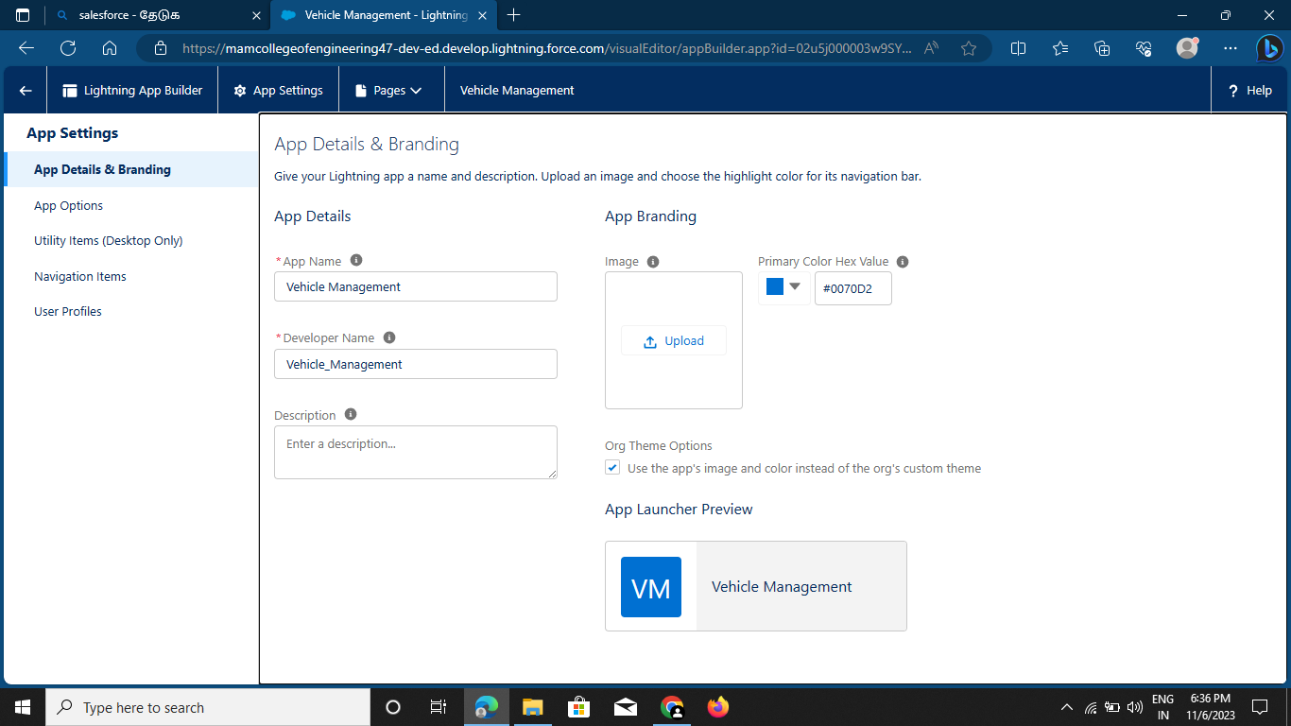



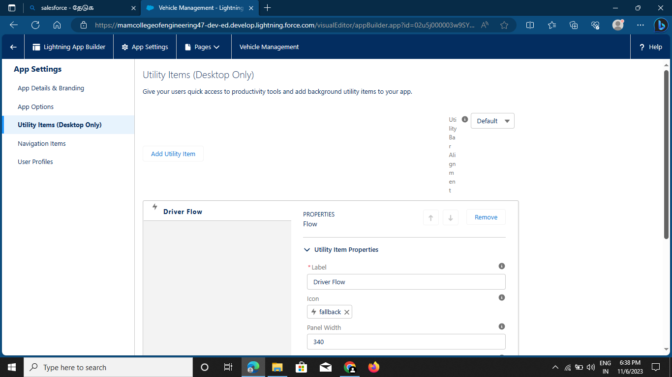

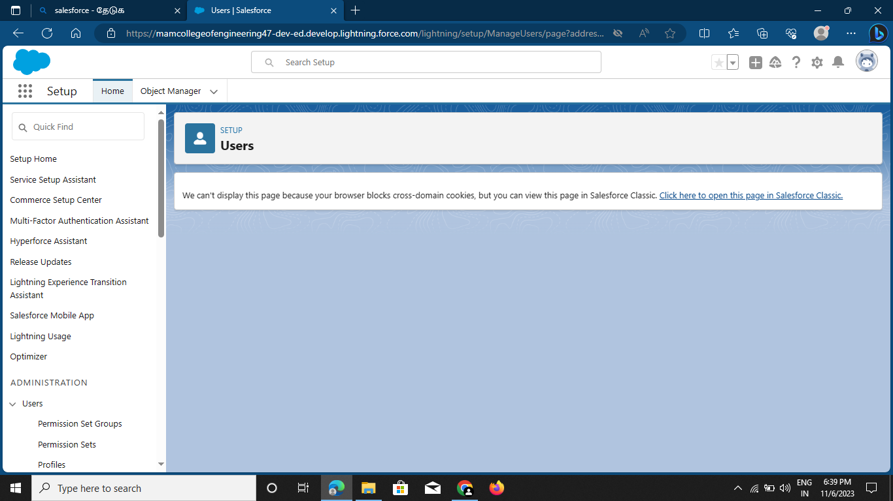

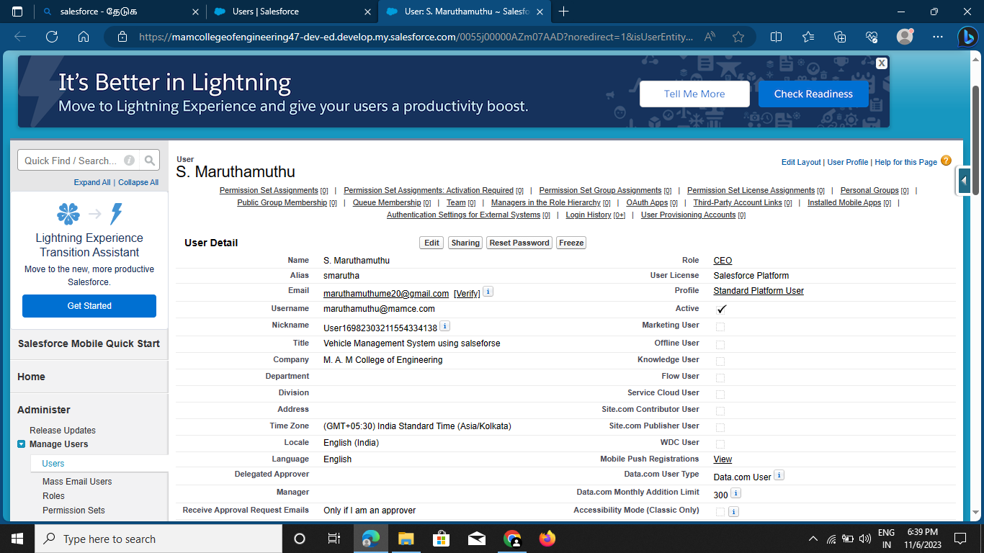

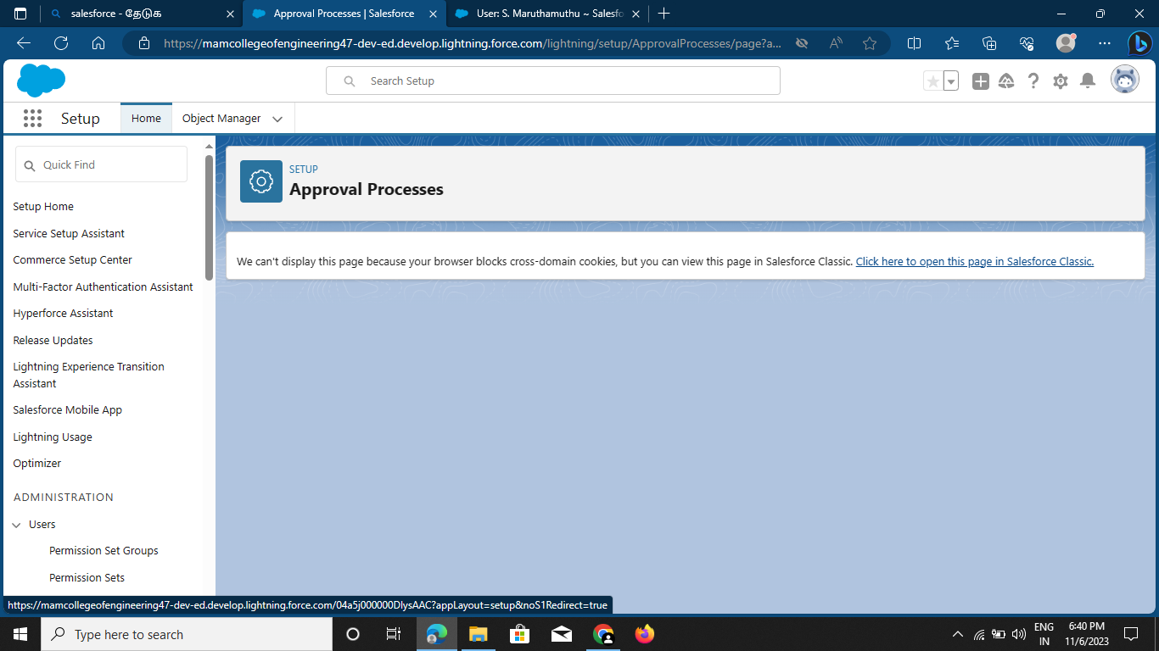

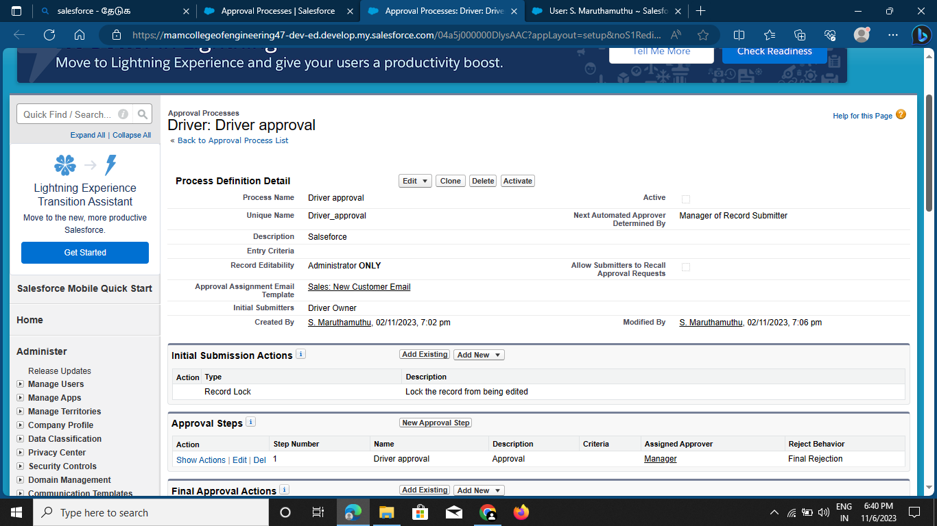

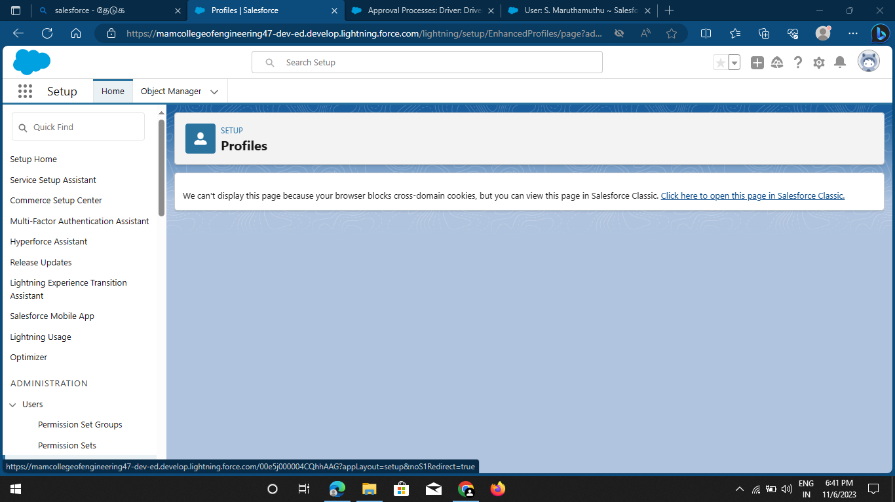

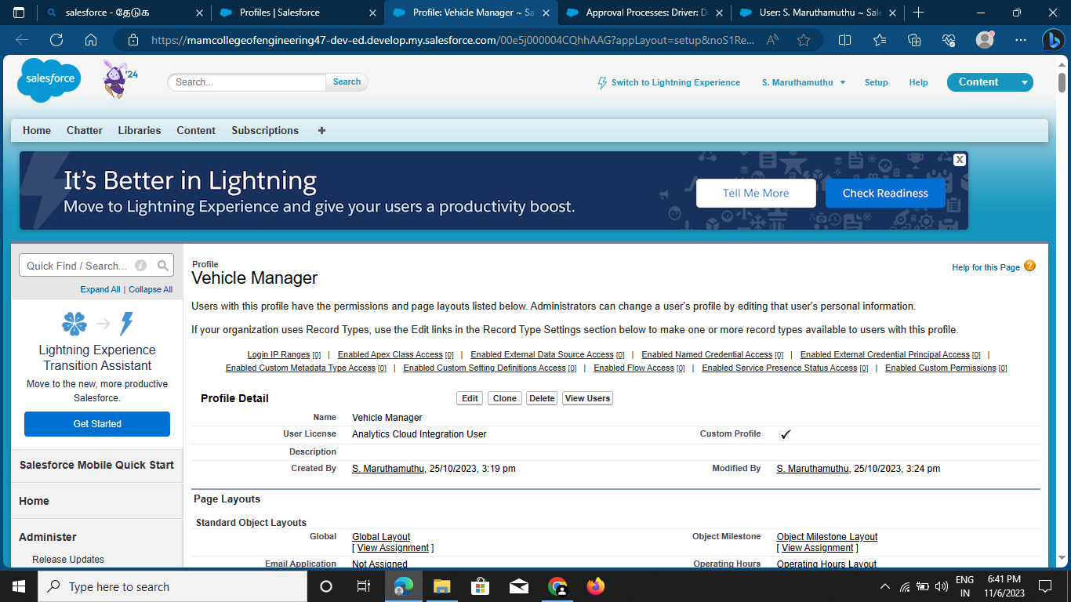

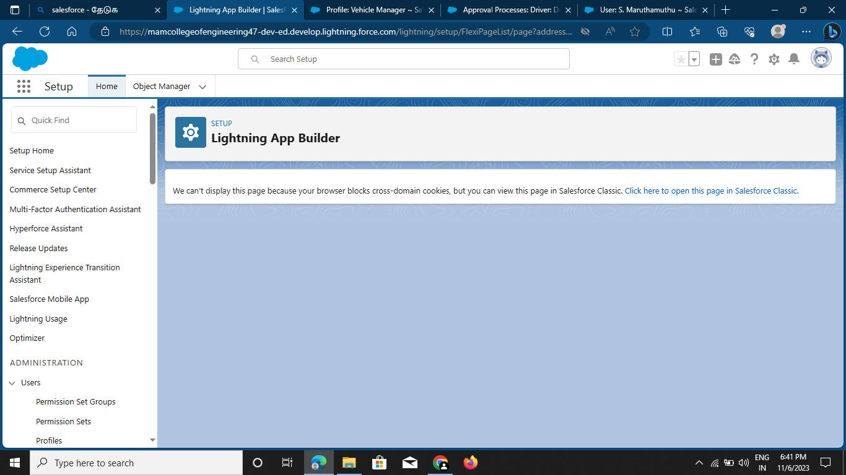

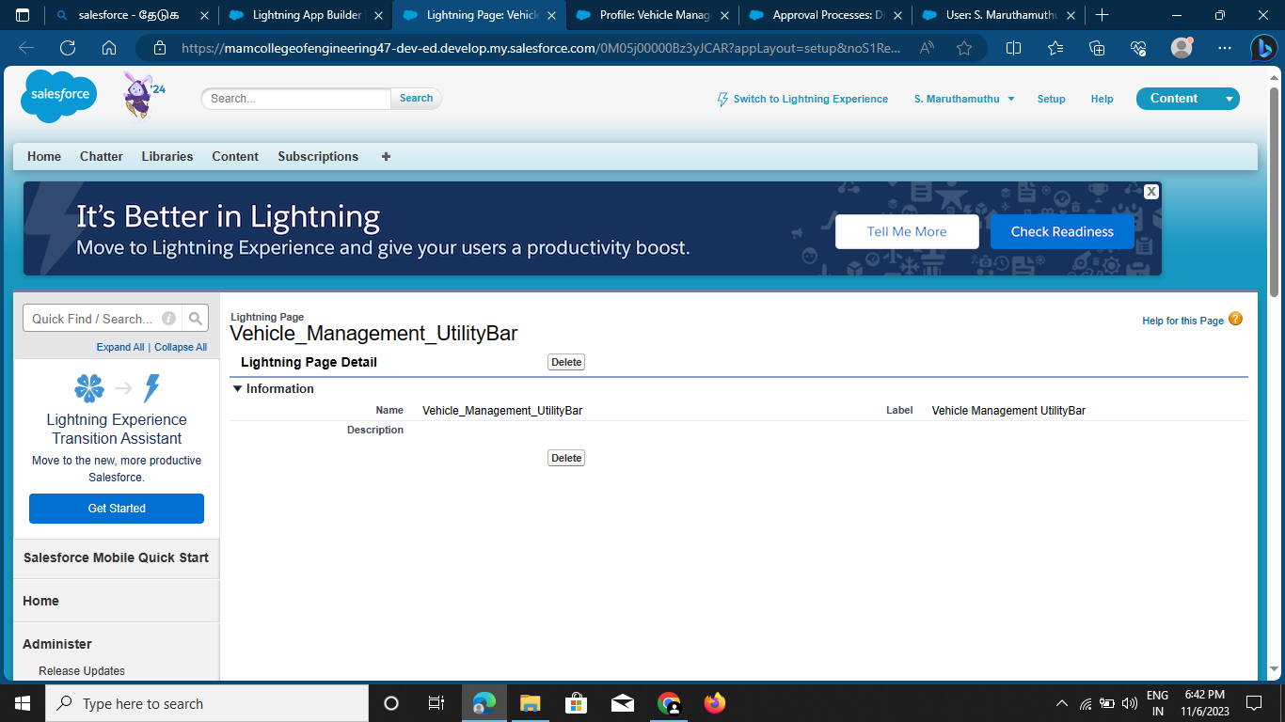

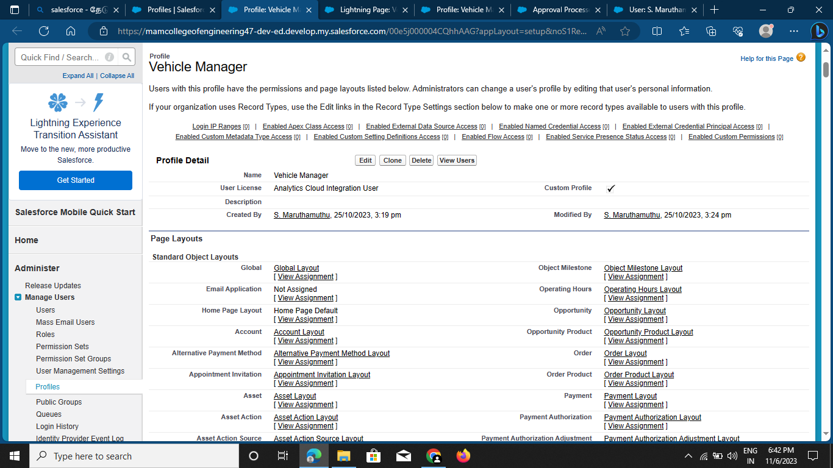

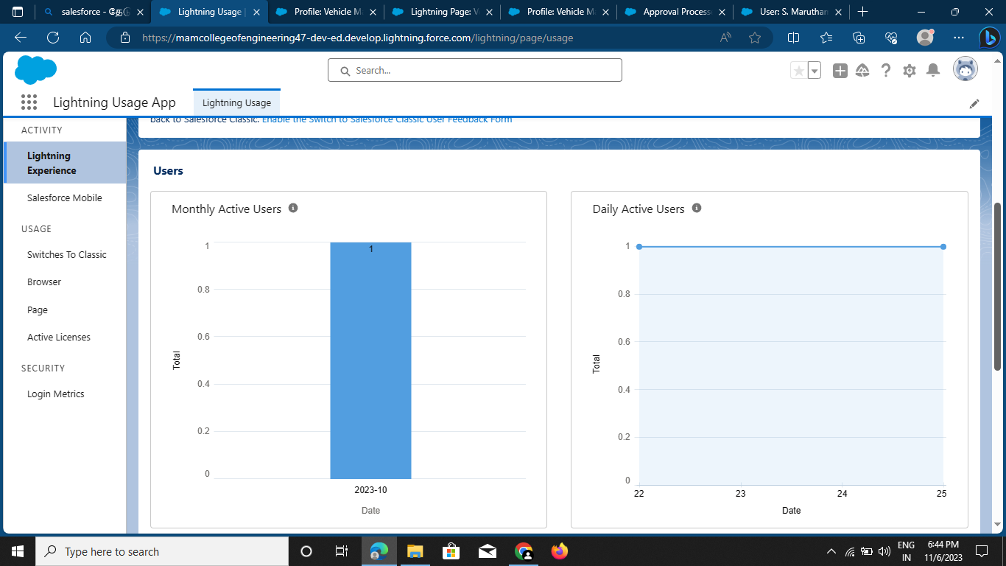

BY TEAM MEMBERS,

S. Maruthamuthu

L.Mohamed ibrahim

S.Mohamed riyasdeen

M.mohamed yahiya